SIG presentation 7th Dec 2017 Bournemouth Uni
Intro
My name is Jim Cowan.
I retired in 2012 from an adult social services dept after 40 years of community development
The thing I did consistently for 4 decades was bring community and civil society people together with statutory system people. This consistently humanised what came out of the statutory services.
Since then I`ve been researching Britain from the standpoint of it being a country with huge potential, but that potential is very far from being realised.
I found two kinds of Britain: a market based one and what Ive been calling a civil society centred one
This presentation is in two parts:
first the Britain based on market thinking our current `operating system`
Second the Britain becoming civil society centred..a far more humanistic Britain in the making and which could well be showing us a future operating system (OS) for the country
On the market thinking side
Market thinking, happening on the surface of society, started life as an economic policy in the 70s,
Then became a policy programme in the 80s and 90s to convert existing bureaucratic public services over to market thinking
But now its now in the culture..its the air we breath (2)
I have fleshed out the thinking and the values that are powering this operating system…As follows:
Money is primary in regulating human behaviour and the performance of organisations (hence benefit sanctions, and payment by results contracts);

Human judgment within public services needs to be replaced with standardised measuring (hence questionnaires and scoring). Public services themselves need to be `measured` (hence audits and inspections).

Because bureaucracy is inherently inefficient, public provision, wherever possible, should be through contracts, which are transparent and ensure accountability.

All public provision should face challenger alternatives (like academies

`Units` of public service should, as far as is possible, be seen as free standing. Competition between units of public provision is fundamentally good because it helps to shake things up.

Human interactions within public services need to conform to centrally laid down criteria and processes. Staff of all kinds need to comply with managements` requirements;

The larger the unit of public service, the better, in terms of reducing unit costs and therefore being more cost-effective

All forms of public service should aim to generate a financial surplus and have private sector-like financial management (hence charging and cost centres)

Private companies and individual entrepreneurs (like landlords) who are taking the risk of offering a public service, should not be penalised (hence the difficulty of getting contracts terminated with clearly dysfunctional contractors or of reforming housing benefit in favour of tenants). They are the wealth creators, and should be treated leniently in any funding regime and incentivised wherever possible;

Public provision benefits individuals and families and therefore their cost should not just be born by the state. Individuals and families should share in the cost. (3)

What this has created is
- A benefits system based on sanctions and work capability
- In 2016, Concentrix, the contracted `provider` charged with policing benefit fraud, had its contract removed because of the sheer weight of complaints.(4)
- The domination of the standards movement in education, crazy figures for NQTs never reaching classrooms or leaving quickly, staff leaving, exclusions etc etc (5)
- A criminal justice system with every single component in a state of overload and crisis. The contracting out of probation is a classic case of how to create a far greater problem and increase the danger to the public.
- And in health and social care
  - Sustained command and control in the NHS
  - Cancellation of urgent ops
  - Consultants, in Henry Marsh`s words felt increasingly like being an unimportant employee in a huge corporation (6)
  - Some nurses in poverty and many leaving
  - Ridiculous hourly rates for home care contracts
  - A crisis in care homes
This is just a tiny fraction of the total picture..just a glimpse
In her Rational Abuse of Organisations, Paula Hyde shows us rational managerial systems aimed at preventing abuse are self-defeating (7),
“…staff who start working with good intentions, in organisations established for positive ends, find themselves causing physical and emotional harm to those they are entrusted to care for”
She further unpacks this
“abuse will not occur if the system is well designed, monitored and managed…in return staff are protected from any criticism……..were procedures and practices followed properly (hospitals-or any public service) would be able to prevent death and suffering…..These encourage staff to suspend thinking and follow procedure…this has dehumanising effects on patients and opens the door to systematic abuse of individuals in the proper conduct of business”
I found myself writing using the metaphor of a room with a fire, more logs are put on the fire but the temperature keeps dropping, because the insulation in the walls is degrading.
Government is now burning fewer and fewer logs (austerity- budget cuts) and the walls are degrading (GPs and teachers leaving, demotivated staff, dysfunctioning organisations etc etc).

Out in the society we have
- homelessness,
- poverty and income inequality,
- malnutrition/foodbanks,
- debt,
- complex conditions,
- poor health,
- obesity,
- drugs,
- prescriptions,
- mental illness,
- suicide,
- hate crime and violence,
Again this is a glimpse of a far larger picture
xxxxxxxxxxxxxxxxxxxxxxxxxxxxxxxxxxxxxxxxxxxxxxxxxxxxxxx
lets now look at the other side of Britain the civil society centred..far more humanistic Britain in the making that my researches have found
I`ll go straight to the thinking and values I`ve unearthed
We all know that ecological thinking is now `out there`. So too sustainability.
But in terms of organisations Laloux (8) shows us numerous examples of organisations now running with no command and control, and his book has sold 100,000 copies with virtually no promotion…there is now a growing community moving organisations towards autonomous teams. Add to this Brian Robertson has developed a methodology for all the people in organisations to run it with no command and control called Holacracy..about 1000 organisations are at various stages. And there is sociocracy too. (9)
And the shift of metaphor is also to one of a city or even Britain itself i.e, something complex and of autonomous units all adapting to one another. As Jean Boulton a complexity specialist put it to me, learn to make the next steps in such a way that gradually constitutes and creates the new realities (10).
The ability of a leadership to have this awareness of the constituting nature of social realities is a departure. So this is another aspect of the values driving this more humanistic Britain: its not about management, its about leadership…a leadership with knows relationships are key. These are leaders who understand about the connectedness of life. They have confidence in peoples capacity for transformation. They are focused on valuing the people they are working with and enabling them to develop themselves. They know everybody is a leader, and everybody in the context has power and a genuine voice.
More prosaically we are beginning to see leaders who value personal integrity, want to be of benefit to others, want what they do to benefit the environment and bring social benefit, and want good organisation (with good tech built in)
We also have thinking from Carol Gould (11) who gives us a ready to go analysis of how freedom, is about our own freely chosen development and therefore actually involves participation with others for shared purpose (which neither liberalism nor socialism have cracked).
And we have John Shotter`s (12) thinking about working from the shared meanings involving the whole group sharing a purpose being the way to make the best kind of change happen..this thinking is capable of replacing the modernist thinking everyone involved in formulating social policies, especially civil servants. I used this consistently in my community development work
When organisations are able to put these kinds of perspectives into practice we find organisations with a heart.
What these kinds of thinking have been used to create are
…the school with the Friday open mic creating a culture of authenticity (in Laloux),
people in meetings able to ring a bell when they think someone is coming from ego (In Laloux)
On benefits
the work of Participle in Wigan, Swindon and Southwark shows in practice a true benefit system which supports people in stuck situations in ways they define and is not just about money..and they move on…(13)
The homeless bus on the Ilse of Wight converted to have beds..goes round the island picking up homeless people, the agencies work to move them on (14).
Feversham primary in Bradford has 6 hours of music a week and is in the top 10% for pupil progress.(15)
the one therapeutic prison Grendon shows amazing results. Restorative justice is taking hold and has uses in care and education.(16)
Merseycare has a zero suicide approach and takes its training into hairdressers and onto building sites (17)
In health and social care your fantastic network and the thinking it is drawing on through the Galvin and Todres book (18)
Also quite large scale new kinds of organisations…..with potential for autonomous teams and the civil society centred mix of thinking and values.
Circle Health (19) running hospitals at Bath and Reading and the largest NHS treatment centre at Nottingham. run by doctors and nurses not managers and all employees are owners. The consultants and healthcare professionals own the facilities they are working in.
or
“Mount Gould is a community hospital run by Plymouth community healthcare, which believes it is the UK’s largest social enterprise providing NHS services. As a community interest company (CIC), it has no shareholders and pays no dividends. It has recently taken over Plymouth’s social care under a £71m deal, making it a pioneer in health and social care integration.” (20)
These are just two examples…the cabinet office has a programe supporting NHS and council services to go independent and become mutuals…run by the staff..there are over a 100 mutuals….
Again this is just a glimpse
Out in society we have
Although politics and economics dominate the news, the centre of gravity, so far as individual lives are concerned, has shifted. It is culture, the arts and education that are shaping the age precisely because they touch people`s lives, enable new thoughts and awarenesses, and transform the human heart. They offer existential freedom. I can become who I really am. What is driving the age has moved on: it is now about using the freedoms, becoming the person I want to become. Giving free play to my abilities: really living my life. The greatest of joys is to be able to create a life for oneself. The resources to do all this are more and more in individuals hands. No one needs elites any more. The routes to a more advanced consciousness are in the hands of ordinary people.
Darren McGarvey (21) put it like this
The new frontier for individuals and movements who want to radically change society is to first recognise the need for radical change within ourselves
This is a human revolution. People are seeking a society with a heart. This passage from Parker Palmer (22) really says a lot for our times
“If you hold your knowledge of self and world wholeheartedly, your heart will at times get broken by loss, failure, defeat, betrayal, or death. What happens next in you and the world around you depends on how your heart breaks. If it breaks apart into a thousand pieces, the result may be anger, depression, and disengagement. If it breaks open into great capacity to hold the complexities and contradictions of human experience, the result may be a new life.
More and more people want organisations and an operating system in the country in which their heart can break open and they can be supported to build new lives.

Just to finish off this idea of Britain having had different operating systems and a new one beginning to form:
Civil society centred Britain
Britain has gone from industrial revolution Britain (OS1):

State Markets Civil Society

To OS2, welfare state Britain:
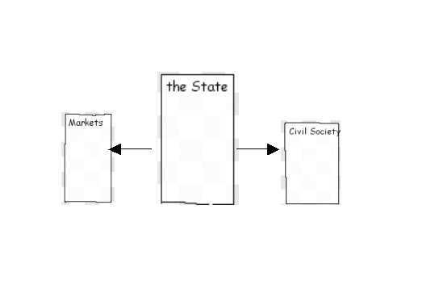

And then to OS3 Market thinking Britain:

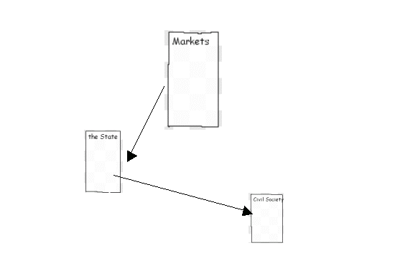

The proposition argued for in this book is that OS4 will
be a civil society centred Britain. It is signalling that it
is coming. Part 3 of my book is scooping these signals up
and making sense of them
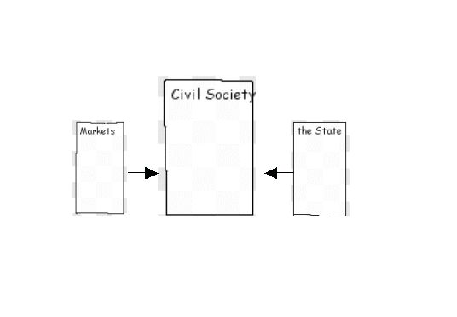
This is a society with a heart
REFERENCES
(1)Brian Robertson uses this metaphor of an operating system in relation to organisations in his book Holacracy (2015, Penguin). What I have done is apply this to Britain as a whole.
(2) Daniel Stedman Jones. Masters of the Universe. Princeton University Press. 2012. This is the best scholarly account of the emergence of market thinking and its spread into society via public services/government. Undoing the Demos. Wendy Brown. Zone Books. 2015 is a strident account of the effects of the spread of market thinking. Not for the faint hearted!
(3) From chapter 4 of my book The Britain Potential
(4) Reported at http://www.bbc.co.uk/news/business-37356646

(5)Ken Robinson has the best account of the standards movement in education : . Creative Schools. Penguin. 2016
(6) Henry Marsh. Admission. 2017. Orion Books
(7) Paula Hyde and Daniel Madge. The Rational Abuse of Organizations. .2007.5th Critical Management Studies Conference. University of Manchester. This is unpublished. But if you google Paula Hyde Manchester University you can access all her publications. https://www.research.manchester.ac.uk/portal/en/researchers/paula-hyde(d34da96a-7e86-4d50-85eb-9818be767edf)/publications.html
(8) Frederic Laloux. Reinventing Organizations. 2014. Nelson Parker
(9) In June of 2015, Robertson released a book, Holacracy: The New Management System for a Rapidly Changing World, that details and explains the practices of Holacracy. Also see sociocracy.co.uk. A second edition on Sociocracy was published in September 2017. For details see http://www.sociocracy.info/people-consenting-deeper-democracy-2nd-edition/. There is a good summary of resources on the web by Martin Grimshaw http://sociocracyuk.ning.com/forum/topics/how-to-find-out-more-about.
(10) Jean Boulton et al. Embracing Complexity. 2015. OUP
(11) Carol Gould. Rethinking Democracy. Cambridge University Press. 1995
(12) ) John Shotter. Conversational Realities . Sage 1993.
(13) http://www.participle.net/
(14) The bus has a website http://thebusshelteriow.co.uk/about-us/. It was reported by the BBC: http://www.bbc.co.uk/news/uk-england-hampshire-38055088
(15) The school`s website is at http://www.fevershamprimaryacademy.org/. Details of the Kodaly method of children learning to play music is at https://en.wikipedia.org/wiki/Kodály_method. The school featured on the BBC One Show on 28/11/17 https://www.bbc.co.uk/iplayer/episode/b09gsfbb/the-one-show-28112017
(16) https://www.theguardian.com/society/2001/feb/02/crime.penal5
(17) Listen to Merseycare NHS Trust. On August 22nd at 8pm Radio 4 broadcast `The Edge of Life`.
(18) ) Kathleen Galvin and Les Todres. Caring and Well-being. Routledge.2013
(19) http://www.circlehealth.co.uk/about-circle/our-partnership

(20) See https://www.theguardian.com/healthcare-network/2015/jul/16/we-wouldnt-go-back-into-the-nhs-plymouths-pioneering-social-enterprise
(21) Darren McGarvey. Poverty Safari. Luath Press. 2017
(22) Parker Palmer. Healing the Heart of Democracy. 2011. Jossey-Bass

