Research with NHS Trusts:
Guidance Sheet for Students and their Supervisors

Much of the health research at Bournemouth University involves collaborating with the NHS and therefore requires Trust approval and in most cases, the approval of the Health Research Authority (HRA) and an NHS Research Ethics Committee (REC). Indeed, it is hoped that such research will make a difference to patients and the NHS. Although there is a Memorandum of Understanding in place between the local Trusts and the University and collaboration agreements drawn-up for individual research projects, this short complementary document suggests some recommendations when carrying out such University-NHS collaborations to assist both students and their supervisors in the smooth running of their research. These recommendations are summarised in Figure 1 whilst Table 1 provides some useful points of contact.

Approaching the Trust
It is first recommended to make contact with the Head of Research, Trust Research Governance, or research facilitators within the NHS Trust(s). This should be done as early as possible and before ethical approval is sought. Although the Trust(s) will require documents such as the full proposal/ protocol for the research, it may be helpful at this point to provide a short plain English summary of the intended research given the extremely busy nature of their roles. By providing this information they will be able to properly assess the feasibility of conducting the study at their site.

Working relationships with the NHS Trust(s) must be built so it is useful to plan a face-to-face meeting for the key people involved i.e. the student, supervisors, R&D staff (manager or facilitator) and BU Clinical Research Coordinator and/or Clinical Governance Advisor. As well as putting faces to names and building rapport, this is an opportunity to clarify expectations and responsibilities as well as legal obligations on both sides (along with anticipated timelines). This also means that assumptions and misunderstandings are minimised which can be common via e-mail correspondence. A meeting will also help identify the key players within the NHS Trust (other than direct supervisors) who will need to be on board for the project to be delivered successfully.

Logistics and processes
At such a meeting, each party will be able to obtain clarity of the often complex processes involved at each institution e.g. HRA, NHS ethics as well as institutional specific policies. The processes have been mapped out for funding applications (with web links), sharing some similarities with student research: https://research.bournemouth.ac.uk/wp-content/uploads/2013/12/Process-v-3.0-October-2018.pdf. For example, confirmation of Trust capacity and capability will be required to conduct the research within the Trust even if NHS ethics is not required e.g. in the case of research with NHS staff. Indeed, it is essential to establish as early as possible what approvals will be required for your research project, and guidance is found here: (https://www.hra.nhs.uk/approvals-amendments/what-approvals-do-i-need/). There are likewise tools available on the Clinical Governance blog, in addition to the more streamlined University ethics process (http://blogs.bournemouth.ac.uk/research/researcher-toolbox/research-ethics/).
Due to the amount of work and number of people involved facilitating the process, the NHS Trust(s) may nominate a main point of contact within the Trust to facilitate/ guide external researchers through the NHS processes. A Clinical Supervisor (Principal Investigator or local collaborator) may also be required for student research. Suzy Wignall is the contact for sponsorship, ethics and clinical governance advice and similarly Juan Campos-Perez from an NHS perspective, both are based at the Lansdowne campus (Table 1).

An honorary contract or research passport may be required in order to work as a ‘guest’ in the Trust(s) i.e. if researchers require patient contact or access to patient records. To apply for an honorary contract you will need to complete a research passport form which can be found via the National Institute for Health Research (NIHR) website, as well as a guidance document detailing what is required based on the ‘employment’ of the researcher. There may also be other mandatory research training requirements such as undergoing training or an update in Good Clinical Practice (http://www.crn.nihr.ac.uk/learning-development/good-clinical-practice/) as well as the University ethics training accessible from Brightspace.

Sponsorship should be discussed early in the process and on a case by case basis. Bournemouth University normally takes responsibility for the sponsorship of student and staff projects (http://blogs.bournemouth.ac.uk/research/files/2012/09/Obtaining-Acceptance-of-Sponsorship-from-Bournemouth-University_SOPs.pdf). However in cases where funding for the research is held by the Trust, or the student is a member of Trust staff, it may be more appropriate for the Trust to take on sponsorship. Please note that sponsorship refers to taking overall responsibility for the study not to be confused with funding the study.

Ongoing communication
There must be regular communication with the Trust(s) since one of their many responsibilities is to monitor their many projects. Indeed, the NHS will need to log such communications including essential documentation e.g. funding confirmation, sponsorship agreement, ethical and governance approvals, and annual reports.

Therefore, it is suggested that appropriate communication mechanisms are agreed upfront during the initial face-to-face meeting e.g. regular meetings in person to update on progress etc. Indeed, some projects may have Advisory Groups/Steering Committees which could incorporate this role. Relevant information to update the Trust(s) on may include timeframes for recruitment and the sharing of findings.

Feedback
Finally, the Trust(s) will require a final report or presentation summarising the overall findings and should be acknowledged where appropriate in any reports and resulting publications etc. Similarly, the research participants themselves should be provided with feedback on the study in an accessible format. It is advised that whenever possible, feedback to patients is provided via their GP/nurse/consultant as opposed to direct contact with participants. Anonymised research data may be kept on BORDaR, the Bournemouth Online Research Data Repository, which is publicly available. However, personal data collected for the purpose of the study (with consent) may be held for five years, from the end of study (PI signed final declaration). Retention periods may differ dependent on the nature of the study.

In summary, it is good practice to make contact with the Trusts as early as possible, establish good working relationships and regular communication channels in order for research to run as smoothly as possible. It is also a good idea to keep the Clinical Governance Advisor/Clinical Research Coordinator up to date with developments or any issues with your project. This is particularly essential for studies sponsored by the University, as in these cases the University has overall responsibility for the study.

Figure 1: Recommendations for researchers working with NHS Trusts

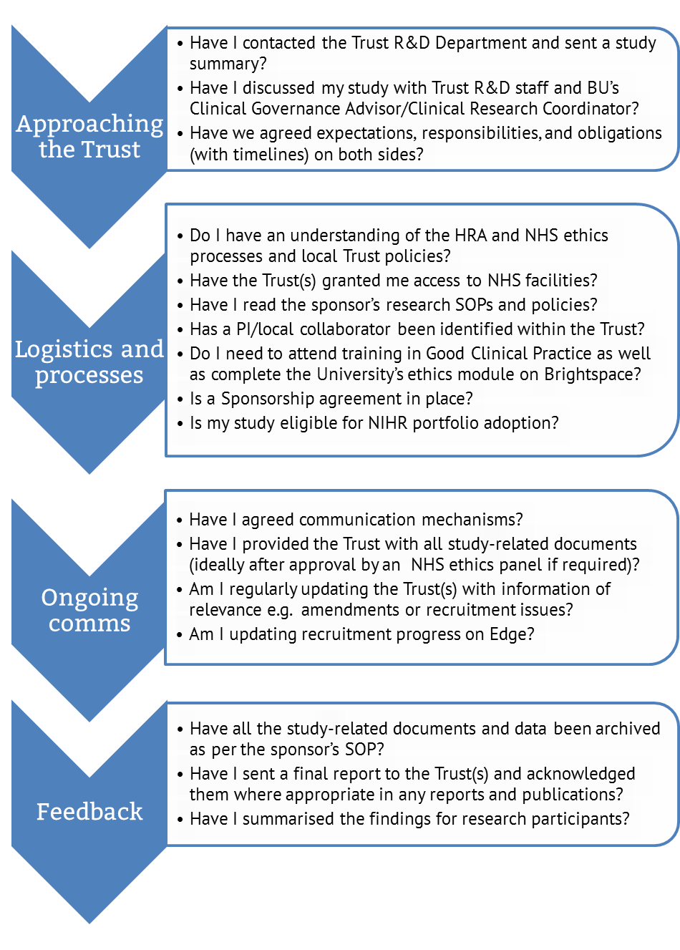

Table 1: Useful contact details for researchers working with NHS Trusts

Organisation | Contact details
Bournemouth University | Louise Bryant  Health and Social Sciences Postgraduate Research Administrator  Tel: 01202 962119  e-mail: fhssresearch@bournemouth.ac.uk  Suzy Wignall (for sponsorship, ethics and clinical governance)  Clinical Governance Advisor  Tel: 01202 961073  e-mail: researchethics@bournemouth.ac.uk  Juan Campos-Perez (for NHS sign-posting and general advice)  Clinical Research Co-ordinator  Tel: 01202 961181  e-mail: jcamposperez@bournemouth.ac.uk
Poole Hospital NHS Foundation Trust | Margaret Younger (headed up by Sarah Chessell)  Research & Innovation Manager Tel: 01202 442982  e-mail: margaret.younger@poole.nhs.uk
Royal Bournemouth and Christchurch NHS Foundation Trust | Laura Purandare (headed up by Caroline Jamieson-Leadbitter)  Research Quality & Improvement Manager  Tel: 01202 962376  e-mail: laura.purandare@rbch.nhs.uk
Dorset County Hospital NHS Foundation Trust | Dr Zoe Sheppard  Head of Research  Tel: 01305 255298  e-mail: zoe.sheppard@dchft.nhs.uk
Dorset HealthCare University NHS Foundation Trust | Dr Ciarán Newell  Facilitator in Research and Development  Tel: 01202 492147  e-mail: c.newell@nhs.net
Portsmouth Hospitals NHS Trust | Elaine Baddeley (headed up by Alice Mortlock)  Research Facilitator  Tel: 02392 286236  e-mail: research.office@porthosp.nhs.uk
Isle of Wight NHS Trust | Tracey Tidbury (headed up by Alexandra Punter)  Research Facilitator  Tel: 01983 552354  e-mail: tracey.tidbury@iow.nhs.uk
University Hospital Southampton NHS Foundation Trust | Headed up by Christine McGrath  Division A: surgery; cancer; critical care and theatres (managed by Hope Howard). Facilitator: Kristine Criste; email: Kristine.criste@uhs.nhs.uk T: 023 8120 8689  Division B: Emergency medicine; medicine for older people; ophthalmology; pathology and specialist medicine: (managed by Shauna Marshall). Facilitator: Emma Perry; email: emma.perry@uhs.nhs.uk; T: 023 8120 5424  Division C: Women and newborn; child health and support services: (managed by Natasha Chigbo). Facilitator: Chloe Sayce; email: chloe.sayce@uhs.nhs.uk T: 023 8120 4245  Division D: Cardiovascular and thoracic; neurosciences; radiology, trauma and orthopaedics: (managed by Emily Watkins). Facilitator: Claire Ayling; email: Claire.ayling@uhs.nhs.uk T: 023 8120 8678  General R&D enquiries:  Tel: 023 8120 5314  e-mail: ResearchManagement@uhs.nhs.uk
Salisbury NHS Foundation Trust | Louise Bell (headed up by Steph Scott)  Research Support Manager  Tel: 01722 425026  e-mail: louise.bell@salisbury.nhs.uk
Yeovil District Hospital NHS Foundation Trust | Nicky Marks(headed up by Joanna Allison)  R&D Facilitator  Tel: 01935 384559  e-mail: nicky.marks@ydh.nhs.uk
Primary Care | Dr Ciarán Newell  Facilitator in Research and Development  Tel: 01202 492147  e-mail: c.newell@nhs.net

A list of contacts can be found on the R&D Forum website.

