Research with NHS Trusts:
Guidance Sheet for Students and their Supervisors

Much of the health research at Bournemouth University involves collaborating with the NHS and therefore requires Trust approval. Indeed, it is hoped that such research will make a difference to patients and the NHS. Although there is a Memorandum of Understanding in place between the local Trusts and the University and collaboration agreements drawn-up for individual research projects, this short complementary document suggests some recommendations when carrying out such University-NHS collaborations to assist both students and their supervisors in the smooth running of their research. These recommendations are summarised in Figure 1 whilst Table 1 provides some useful points of contact.

Approaching the Trust
It is first recommended to make contact with the Research and Development Manager within the NHS Trust(s). This should be done as early as possible and before ethical approval is sought. Although the Trust(s) will require documents such as the full proposal/ protocol for the research, it may be helpful at this point to provide a short plain English summary of the intended research given the extremely busy nature of their roles.

Working relationships with the NHS Trust(s) must be built so it is useful to plan a face-to-face meeting for the key people involved i.e. the student, supervisors, and the Research and Development Manager in the Trust(s). As well as putting faces to names and building rapport, this is an opportunity to clarify expectations and responsibilities as well as legal obligations on both sides (along with anticipated timelines). This also means that assumptions and misunderstandings are minimised which can be common via e-mail correspondence.

Logistics and processes
At such a meeting, each party will be able to obtain clarity of the often complex processes involved at each institution e.g. ethics and governance approval processes as well as institutional specific policies. The processes have been mapped out for funding applications (with weblinks), sharing some similarities with student research: https://research.bournemouth.ac.uk/wp-content/uploads/2013/12/BUNHS-Combined-Research-Process-V2.pdf. For example, approval will be required to conduct the research within the Trust even if NHS ethics is not required e.g. in the case of research with NHS staff. Indeed, it is essential to establish whether the research requires comprehensive NHS ethical approval (https://www.myresearchproject.org.uk/Signin.aspx) in addition to the more streamlined University ethics process (http://blogs.bournemouth.ac.uk/research/researcher-toolbox/research-ethics/).
Due to the amount of work and number of people involved facilitating the process, the NHS Trust(s) may nominate a main point of contact within the Trust to facilitate/ guide external researchers through the NHS processes. A Clinical Supervisor may also be required for student research depending on the nature of the research and clinical experience of the student. Eva Papadopoulou is the contact for ethics and governance advice from the University perspective and similarly Laura Purandare from the NHS perspective, both based at the Lansdowne campus (Table 1).

An honorary contract or research passport may be required in order to work as a ‘guest’ in the Trust(s) i.e. if researchers require patient contact or access to patient records. There may also be other mandatory research training requirements such as undergoing training or an update in Good Clinical Practice (http://www.crn.nihr.ac.uk/learning-development/good-clinical-practice/) as well as the University ethics training accessible from the MyBU online portal.

Sponsorship should be discussed early in the process and on a case by case basis. Bournemouth University normally takes responsibility for the sponsorship of students (http://blogs.bournemouth.ac.uk/research/files/2012/09/Obtaining-Acceptance-of-Sponsorship-from-Bournemouth-University_SOPs.pdf). However in cases where funding for the research is held by the Trust, or the student is a member of Trust staff, it may be more appropriate for the Trust to take on sponsorship. Please note that sponsorship refers to taking overall responsibility for the study not to be confused with funding the study.

Ongoing communication
There must be regular communication with the Trust(s) since one of their many responsibilities is to monitor their many projects. Indeed, the NHS will need to log such communications including essential documentation e.g. funding confirmation, sponsorship agreement, ethical and governance approvals, and annual reports.

Therefore, it is suggested that appropriate communication mechanisms are agreed upfront during the initial face-to-face meeting e.g. regular meetings in person to update on progress etc. Indeed, some projects may have Advisory Groups/Steering Committees which could incorporate this role. Relevant information to update the Trust(s) on may include timeframes for recruitment and the sharing of findings.

Feedback
Finally, the Trust(s) will require a final report or presentation summarising the overall findings and should be acknowledged where appropriate in any reports and resulting publications etc. Similarly, the research participants themselves will require feedback on the study in an accessible format.

In summary, it is good practice to make contact with the Trusts as early as possible, establish good working relationships and regular communication channels in order for research to run as smoothly as possible.

Figure 1: Recommendations for researchers working with NHS Trusts

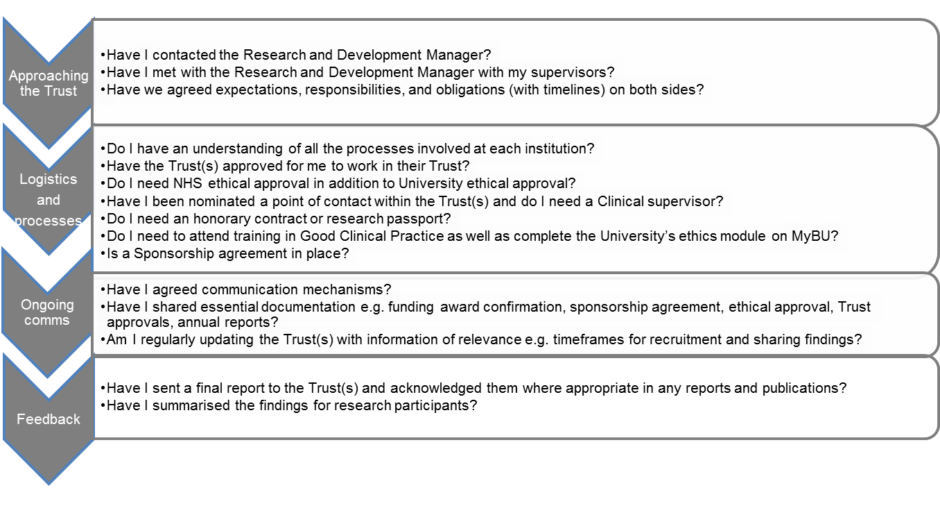

Table 1: Useful contact details for researchers working with NHS Trusts
Organisation | Contact details
Bournemouth University | Louise Bryant  Health and Social Sciences Postgraduate Research Administrator  Tel: 01202 962119  e-mail: hscresearch@bournemouth.ac.uk  Eva Papadopoulou  Research Ethics and Governance Adviser  Tel: 01202 968262  e-mail: researchethics@bournemouth.ac.uk  Lisa Gale-Andrews (for sign-posting and general advice)  Clinical Research Co-ordinator  Tel: 01202 962172  e-mail: lgaleandrews@bournemouth.ac.uk
Poole Hospital NHS Foundation Trust | Margaret Younger (headed up by Sarah Chessell)  Senior Project Manager  Tel: 01202 442982  e-mail: margaret.younger@poole.nhs.uk
Royal Bournemouth and Christchurch NHS Foundation Trust | Laura Purandare (headed up by Caroline Jamieson-Leadbitter)  Research Monitor  Tel: 01202 962376  e-mail: laura.purandare@rbch.nhs.uk
Dorset County Hospital NHS Foundation Trust | Christopher Miller  Research and Development  Tel: 01305 255298  e-mail: christopher.miller@dchft.nhs.uk
Dorset HealthCare University NHS Foundation Trust | Ciaran Newell  Facilitator in Research and Development  Tel: 01202 492147  e-mail: ciaran.newell@dhuft.nhs.uk
Portsmouth Hospitals NHS Trust | Greta Westwood (headed up by Anoop Chauhan)  Deputy Director of Research and Innovation  Extension: 3185  e-mail: greta.westwood@porthosp.nhs.uk
Isle of Wight NHS Trust | Tracy Tidbury (headed up by Alexandra Punter)  Research Governance Officer  Tel: 01983 552354  e-mail: tracey.tidbury@iow.nhs.uk
University Hospital Southampton NHS Foundation Trust | Ailisa Duckworth (headed up by Christine McGrath)  Head of Research and Development  Tel: 023 8120 6083  e-mail: ailsa.duckworth@uhs.nhs.uk
Salisbury NHS Foundation Trust | Louise Bell (headed up by Steph Scott)  Research Support Manager  Tel: 01722 425026  e-mail: louise.bell@salisbury.nhs.uk
Yeovil District Hospital NHS Foundation Trust | Barbara Williams-Yesson  R&D/Clinical Trials Manager  Tel: 01935 384559  e-mail: Barbara.Williams-Yesson@YDH.NHS.UK
Primary Care | Ciaran Newell  Facilitator in Research and Development  Tel: 01202 492147  e-mail: ciaran.newell@dhuft.nhs.uk

